Make a Simple Pioneer Trek Apron

It takes 1 yard of 45" wide fabric to make a simple pioneer apron.
Buy 1 1/8 yard of fabric to make an apron for someone tall.
Use a yardstick and pencil to mark the pieces. Cut the fabric according to the diagram:
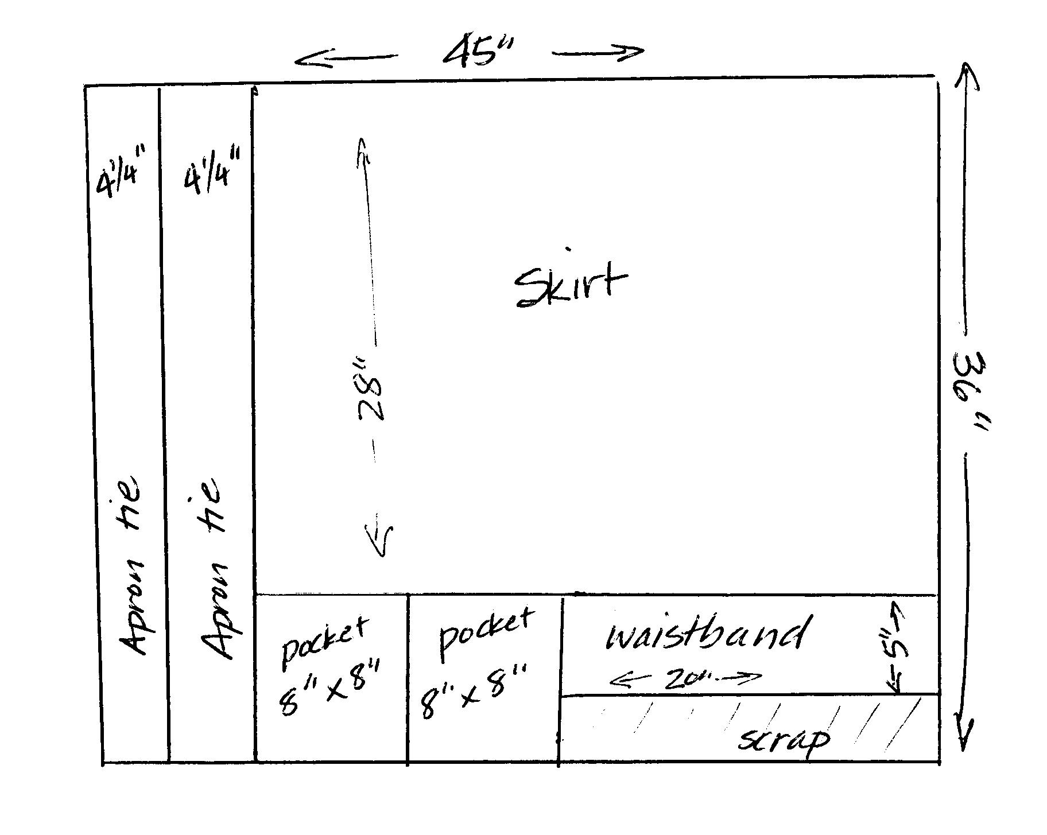
You need:
two ties, measuring 4 ¼" by 36"
one waistband measuring 20" by 5"
one skirt measuring 36" by 28"
( or 36" by 32" for a tall person)
two pockets 8" by 8"

On the apron skirt:

1. Stitch down a very narrow hem on each side of the apron skirt.
2. Stitch down a 2" hem across the bottom of the apron.
3. Make gathering stitches across the top edge of the apron skirt. Using the longest stitch on your machine, sew across the top of the skirt, ½" down from the top. Sew a second row of stitches about ¼" down from the first row.
4. Add pockets to the apron skirt.
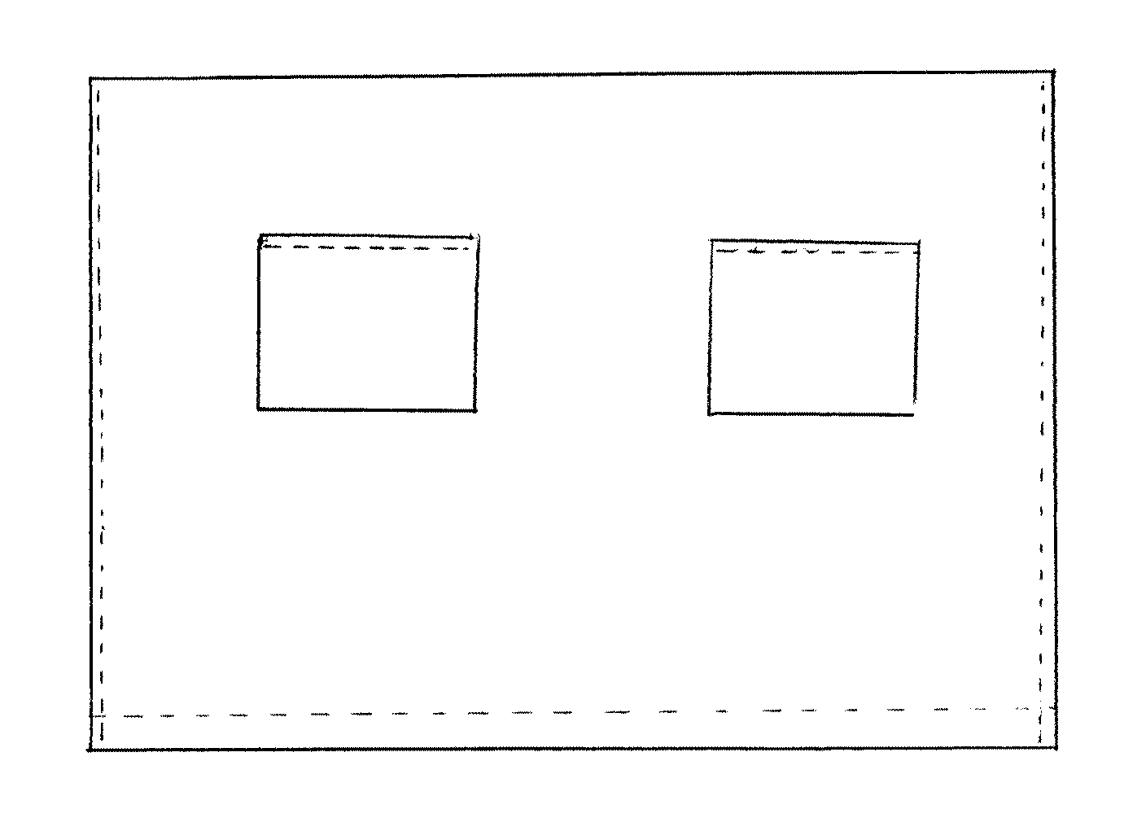
Apron pockets:
1. Stitch a narrow hem along one edge of each pocket.
2. On each of the other three sides of the pocket, fold the fabric over to the wrong side about 1/3" and press down. Pin in place.
3. The hemmed edge of the pocket is the top. Pin the pockets in place on the apron skirt the tops of the pockets about 6-7 inches from the top of the skirt, and the outside edge of the pockets about 7-8" from the outside edge of the skirt.
4. Top stitch over the three sides of the pockets about 1/8" from the outside edge. Be sure to backstitch and go over the top corners more than once to keep the pocket secure while in use.

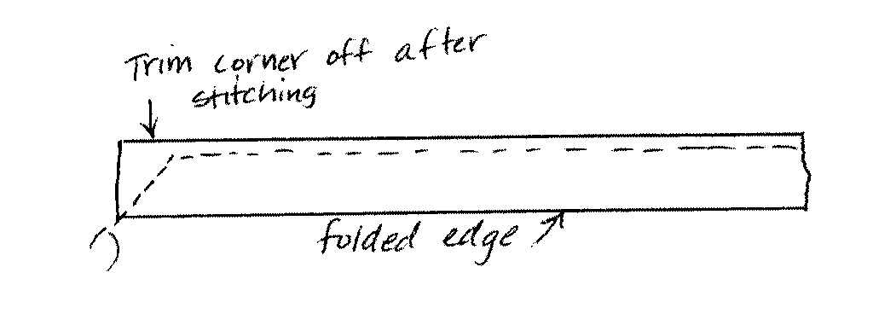
For the apron ties:
1. Fold each tie in half lengthwise with right sides together and pin. Sew diagonally across one end and down the length of the side to make a tube.
2. Clip the corner on the end of the tie and turn inside out.
3. Press the tie flat with the seam on one side.

For the waistband:
1. Gather the apron skirt until it is ½" shorter than the length of the waistband.
2. Pin the right side of the skirt to the right side of one edge of the waistband, leaving ¼" on each end. Stitch the skirt and waistband together.
3. Pin the raw edge of the side ties to each end of the waistband right next to the skirt.
And stitch in place.
4. Fold the waistband over in half so the right sides are together and ends of the side ties are in between.
5. Sew each end of the waistband together, securing the ends of side ties in the middle.
6. Turn the ends inside out. Fold the raw edge of the waistband under ¼ inch and pin in place along the back side of the skirt and waistband seam. Top stitch in place.

